Additional Figures & Table

The following provides a clear version of the figures in the paper and the figures that cannot fit in the original paper due to space limitations. In addition, it also contains a table of 20 drugs predicted for AD in the original paper 4.4 case study part.

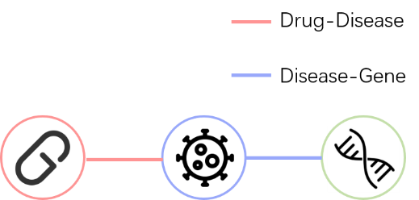

**Fig. 1.** Nodes and Edges used

Our dataset bioDDG contains three types of nodes and two types of edges

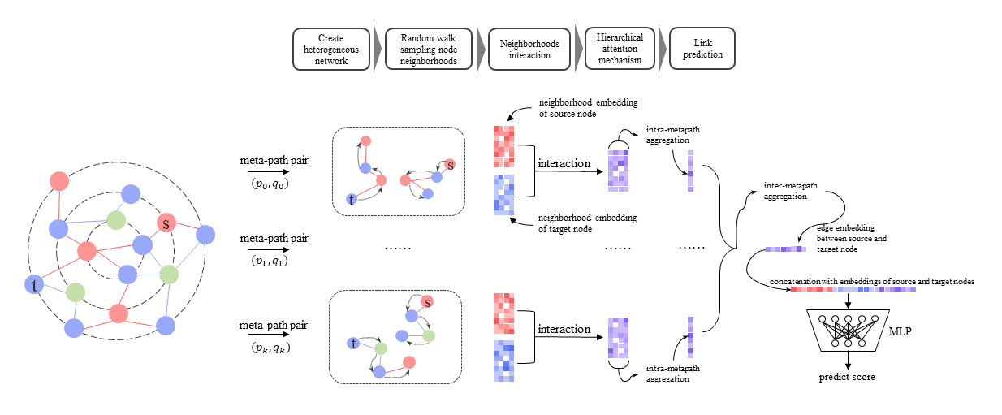

**Fig. 2.** The workflow of the NIEE

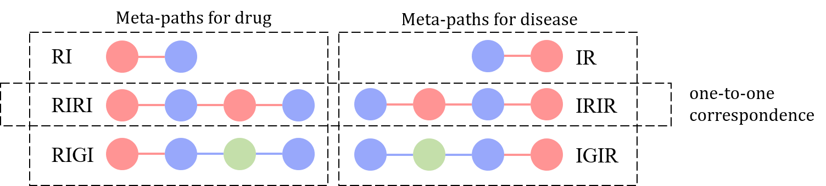

**Fig. 3.** Meta-path pairs

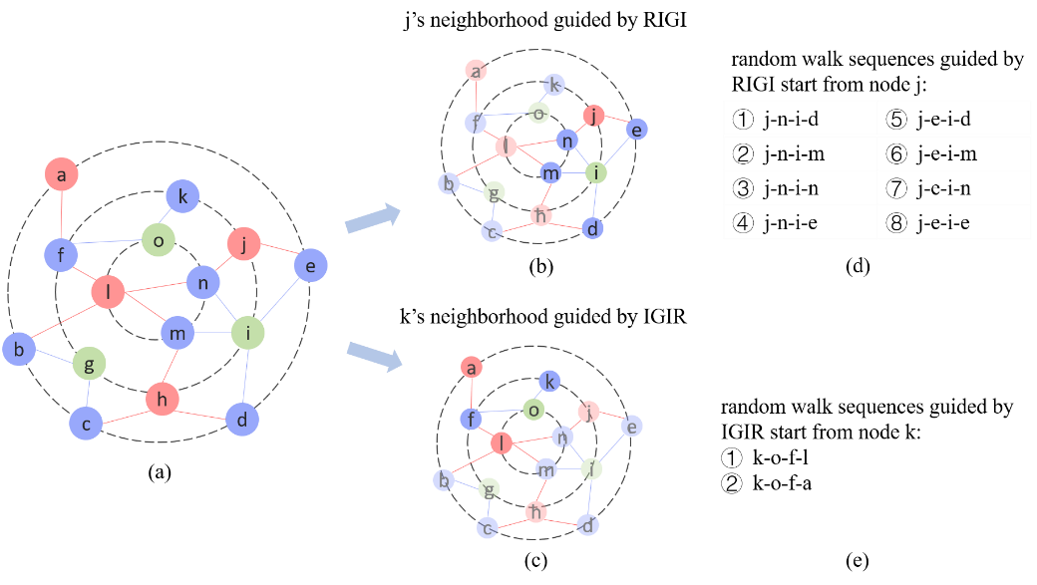

**Fig. 4.** Neighborhoods guided by meta-paths for given nodes (take RIGI & IGIR as example)

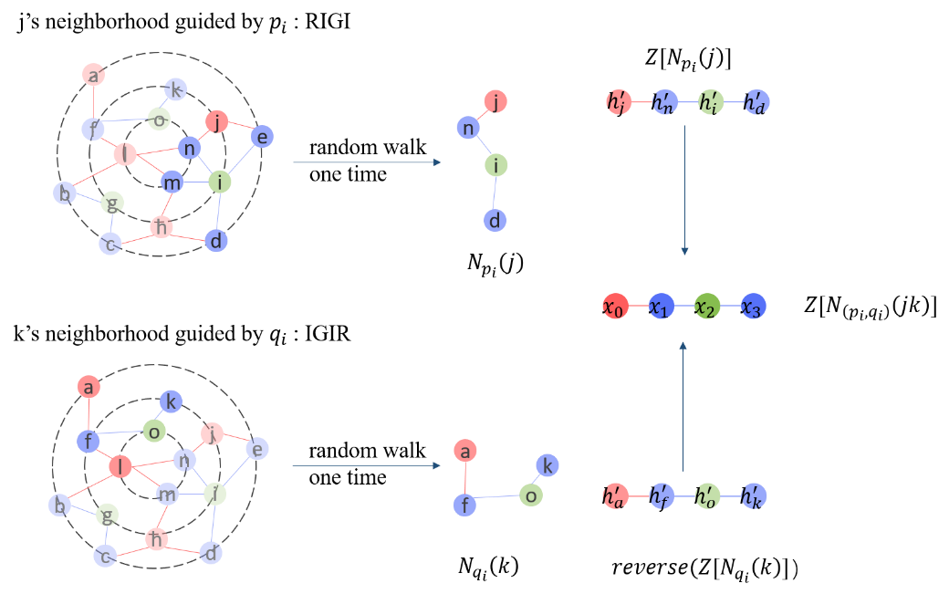

**Fig. 5.** Example of interaction between neighborhoods (take the meta-path pair RIGI & IGIR as an example)

For the convenience of demonstration, random walk is performed only once in the above figure.

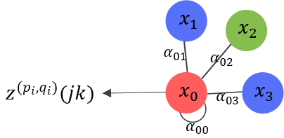

**Fig. 6.** Example of embedding representation of $z^{(p_{i},q_{i})}(jk)$ learned by single-head self-attention mechanism

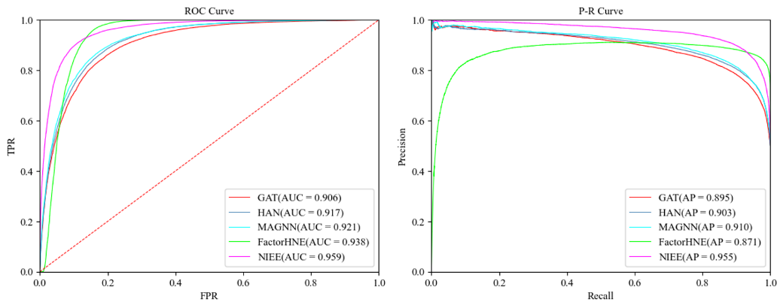

**Fig. 7.** NIEE's performance in comparison to other benchmark models.

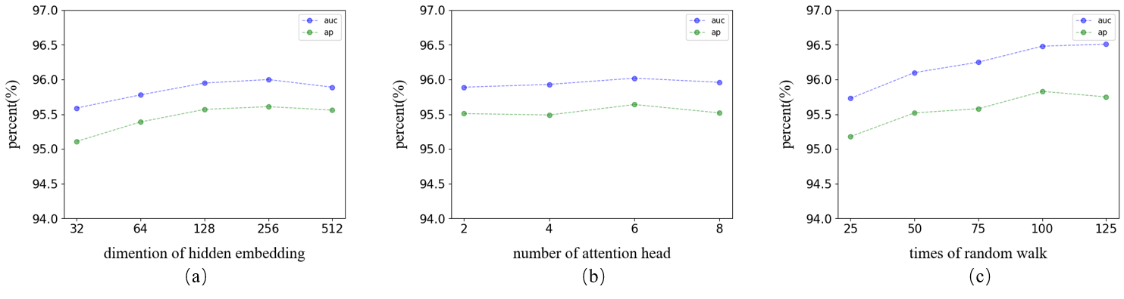

**Fig. 8.** Sensitivity analysis of parameters.

**Table 1.** 20 potential drugs for Alzheimer's disease predicted by NIEE.

|  |  |  |  |  |  |  |  |
| --- | --- | --- | --- | --- | --- | --- | --- |
| Rank | Predicted drugs | DrugBank ID | Evidence | Rank | Predicted drugs | DrugBank ID | Evidence |
| 1 | Seviteronel | DB12275 |  | 11 | Methylphenidate | DB00422 | CTD, [2,3] |
| 2 | Abarelix | DB00106 |  | 12 | Dopexamine | DB12313 |  |
| 3 | Aminoglutethimide | DB00357 | CTD | 13 | Lactitol | DB12942 |  |
| 4 | Volinanserin | DB16351 |  | 14 | Dopamine | DB00988 | CTD |
| 5 | Kynurenic Acid | DB11937 | CTD | 15 | Moxaverine | DB12251 |  |
| 6 | Ipragliflozin | DB11698 |  | 16 | Tetrabenazine | DB04844 | [4] |
| 7 | Tretazicar | DB04253 |  | 17 | Benfluorex | DB09022 |  |
| 8 | Metronidazole | DB00916 | CTD | 18 | Alprostadil | DB00770 | CTD |
| 9 | Racephedrine | DB14752 |  | 19 | Dexamethasone  acetate | DB14649 | CTD, [5] |
| 10 | Resveratrol | DB02709 | CTD, [1] | 20 | Methylprednisolone hemisuccinate | DB14644 | CTD, [5] |

1. Sawda C, Moussa C, Turner RS. Resveratrol for Alzheimer's disease. Ann N Y Acad Sci. 2017 Sep;1403(1):142-149. doi: 10.1111/nyas.13431. Epub 2017 Aug 16. PMID: 28815614; PMCID: PMC5664214, (2017).
2. Mintzer J, Lanctôt KL, Scherer RW, Rosenberg PB, Herrmann N, van Dyck CH, Padala PR, Brawman-Mintzer O, Porsteinsson AP, Lerner AJ, Craft S, Levey AI, Burke W, Perin J, Shade D; ADMET 2 Research Group. Effect of Methylphenidate on Apathy in Patients With Alzheimer Disease: The ADMET 2 Randomized Clinical Trial. JAMA Neurol. 2021 Nov 1;78(11):1324-1332. doi: 10.1001/jamaneurol.2021.3356. PMID: 34570180; PMCID: PMC8477302, (2021).
3. Rosenberg PB, Lanctôt KL, Drye LT, Herrmann N, Scherer RW, Bachman DL, Mintzer JE, ADMET Investigators. Safety and efficacy of methylphenidate for apathy in Alzheimer's disease: a randomized, placebo-controlled trial. J Clin Psychiatry. 2013 Aug;74(8):810-6. doi: 10.4088/JCP.12m08099. PMID: 24021498; PMCID: PMC3902018, (2013).
4. Kilbourn MR, DaSilva JN, Frey KA, et al. In vivo imaging of vesicular monoamine transporters in human brain using [11C] tetrabenazine and positron emission tomography. J Neurochem;60:2315–8, (1993).
5. Alisky JM. Intrathecal corticosteroids might slow Alzheimer's disease progression. Neuropsychiatr Dis Treat. 2008 Oct;4(5):831-3. doi: 10.2147/ndt.s3685. PMID: 19183775; PMCID: PMC2626920, (2008).